The NSG Group at the BAU 2017 in Munich
Pilkington Deutschland AG, Bauglasindustrie GmbH (BGI) and Pilkington Austria GmbH – all part of the NSG Group – will present the latest innovations of the business lines/product groups Fire Protection Glass, Glass Systems and Design Glass at BAU 2017 exhibition in Munich, Germany from 16th to 21st of January 2017.
BAU 2017, that is “… the Leading Trade Fair for Architecture, Materials and Systems, …” on 183,000 m² of floor space, equivalent to the size of 25 football pitches, presenting State-of-the-Art technologies from the International Construction Industry. “It sets standards and is the industry's most important gathering.” It has become a vital source of information and inspiration for architects around the world. Visitors of the corporate stand 328 in Hall C2 will have the opportunity to gather information and to get expert advice on the latest system and product developments. The NSG Group offers a wide range of high performance glass products. With its world renown global network of branches and production sites it is able to deliver sustainable and innovative solutions using transparent glass products for various highly complex building projects which require professional order processing and customer service.
The special focus of the fire protection glass business unit of the Pilkington Deutschland AG at the BAU 2017 are the latest developments of the butt-jointed solutions of the series of “Line” products, on display in various configurations and design options. Whether it is monolithic, filigree solutions, mechanically stronger IGU-combinations, design features or even a “corner” solution, Architects and Engineers are given the choice. A further trade fair highlight is a newly developed, monolithic, 47 mm thick Pilkington Pyrostop® for the fire resistance classification EI 120.
Bauglasindustrie GmbH, Schmelz, will focus on energy efficiency and triple glazed setups comprising Pilkington Profilit™ „one in 2“ and „2 plus one“ featuring a new Pilkington Profilit™ Low-E-Plus coating. Low emissivity performance with U_{g}-values as low as 0.61 W/m²K and sound insulation performance with an R_{w}-values of up to 57 dB can be achieved. Furthermore safety and design features with various decorative options and the unique range of colour choices will be on display. Newly developed solutions to combine Pilkington Profilit™-Façades with curtain walling systems will also be presented.
Pilkington Austria GmbH will present amongst other products the new antireflective glass Pilkington OptiView™ Ultra. Pilkington OptiView™ Ultra raises the transparency of glass to a new level, by reducing its typical reflection to a minimum. A further highlight is the presentation of Pilkington Mirropane™ Chrome Plus. The chrome mirror stands out with its high level of opacity and with its light transmittance of only 0.1 per cent, it is nearly “non-see-through”. The trade show will also be a perfect opportunity to present Pilkington Design Glass. This temperature and high impact resistant glass is great for use in kitchen and bathroom areas due to its very strong anti-scratch surface. Pilkington Design Glass is available in a variety of RAL-colours thus combining a high quality of finish with personal preference.
Our team of Sales, Marketing and Technical Experts is looking forward to welcoming customers and visitors to the BAU 2017. Visit us in Hall C2, stand 328.

Image 1
File: Pilkington_Stand_BAU_2017.jpg

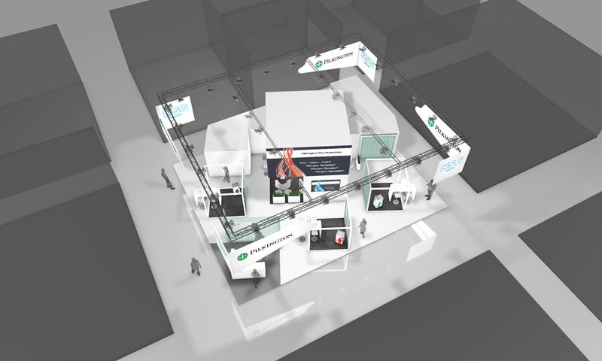
Preview: The NSG Group stand at the BAU 2017

Image 2
File: Pilkington_BAU_Banner_INT.jpg

