The NSG Group to Exhibit at Glasstec 2024 in Dusseldorf
28 June, 2024

PRESS RELEASE

The NSG Group, renowned for manufacturing glass under the Pilkington brand, will showcase its latest innovations at Glasstec 2024, the world’s leading glass industry trade fair, in Dusseldorf from 22-25 October 2024.
The theme, this year, at the NSG Group stand, will be the new makechange™ platform implemented in all activities towards achieving the Group's sustainability goals.

Visitors to stand G20 in Hall 10, will be able to explore the newly introduced value-added products and innovative solutions suitable for a wide range of architectural projects, regardless of challenges and budget constraints.

Key Exhibits and Innovations

Pilkington Mirai™: this latest product boasts 52% lower embodied carbon compared to standard float glass and, as the market-leading low carbon glass, will play a key role in sustainable design. Launched in October last year, Pilkington Mirai™ is offered as a low carbon alternative to regular float glass, with no difference in performance, quality, or aesthetics. It is a pioneering glass produced using a combination of alternative fuel, high recycled glass content, and green electricity sources.
The NSG Group will also unveil the brand new HomeComfort range. In the HomeComfort meeting room visitors will be able to see HeatComfort and LuxComfort products in action. The stand will also exhibit an Infrared Glass Radiator – the HeatComfort solution powered by NSG TEC™. HeatComfort is a range of products using the NSG Group technology of electrically conductive coatings to redefine the concept of comfort.
Pilkington Sunplus™ BIPV, also showcased, is the solution that includes Building Integrated Photovoltaics (BIPV) to enable buildings to generate energy as an eco-friendly and aesthetically pleasing alternative to traditional energy sources.

Pilkington AviSafe™ features glass with a special coating designed to help prevent birds from colliding with the windows and façades of buildings. Its UV enhanced pattern is more visible to birds than humans, ensuring maximum transparency while maintaining architectural appeal. The combination of bird-safe glass with superior performance solar control glass Pilkington Suncool™ Q will also be presented at the show. Pilkington AviSafe Suncool™ Q 70 is a neutral, superior solar control glass with high colour stability, low reflection and superb selectivity offering protection to birds.

Also on show will be the toughenable product from the Pilkington Suncool™ Q range, the latest solar control glass with the lowest reflectance on the market. The range includes three products: Pilkington Suncool™ Q 50, Pilkington Suncool™ Q 60 and Pilkington Suncool™ Q 70, all featuring high colour stability, low reflectance and very high selectivity. The Q-range of coatings are characterised by varying levels of light transmission and g-value and provide a uniform appearance that allows different types of glass to be easily combined in the same building. Two products in the range are also available in versions suitable for toughening, Pilkington Suncool™ Q 60 Pro T and Pilkington Suncool™ Q 70 Pro T.
Pilkington OptiView™ Ultra Protect, an extra clear laminated glass with anti-reflective coatings on surfaces #1 and #4, will be presented as single glass and in an insulated glass unit. The product offers total visible light reflection reduced to 1% and enables the best possible viewing properties.

Finally, highlighted at the stand will be a wall of Pilkington Pyrostop® Line fire protection glass, available in resistance classes from EI 30 to EI 120. Featuring only a thin vertical silicone joint between the panes, the product is suitable for long panoramic walls built without vertical profiles.

These are just some of the solutions to be presented at the exhibition stand, where visitors can also learn more about the full product range through an on-line Global Product Directory.

The NSG Group team at Glasstec looks forward to meeting customers and visitors interested in how Pilkington glass solutions can benefit them.
Visit the NSG Group at booth #10-G20.
For more information please visit: www.pilkington.com
ENDS
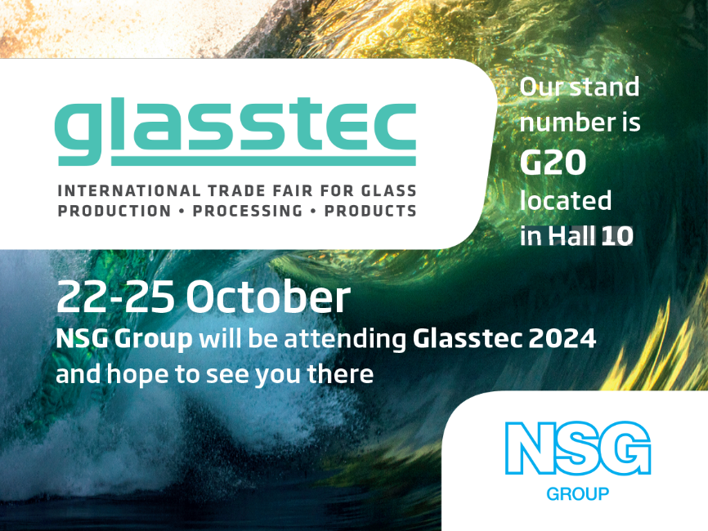

Photo: NSG Group to exhibit at Glasstec 2024
Note to editors:
About the NSG Group (Nippon Sheet Glass Co. Ltd., and its group companies)
The NSG Group is the world's leading supplier of glass and glazing systems in the business areas of Architectural, Automotive and Creative Technology. In 2006, it acquired the leading global glass supplier, Pilkington, and today, the Group has principal operations around the world and sales in more than 100 countries. Architectural manufactures and supplies architectural glass as well as glass for the solar energy and other sectors. Automotive serves the original equipment (OE) and aftermarket replacement (AGR) glazing markets. Creative Technology comprises several discrete businesses, including lenses and light guides for printers and scanners, and specialty glass fibre products such as glass cord for timing belts and glass flake.
For more information about NSG Group visit: www.nsg.com

