Pilkington Sunplus™ BIPV powered by Solaria receives IEC Certification
PRESS RELEASE
PR/007/17
10th July, 2017

NSG Group’s Architectural Glass Solar Products Certified to Global Design and Safety Standards
NSG Group, the owner of the Pilkington brand, and one of the world’s largest glass producers, and Solaria Corporation, global provider of solar module technologies, today announced that the Pilkington Sunplus™ BIPV powered-by-Solaria has passed stringent testing by Kiwa Netherlands according to IEC61215 and IEC61730 certification standards. The receipt of this certification from Kiwa confirms that Pilkington Sunplus™ BIPV architectural solar products comply with the product safety, design and quality tests. Pilkington Sunplus™ BIPV is powered by Solaria’s PowerVision™ technology, an architectural solar glass solution that combines attractive aesthetics with effective daylighting, glare control, superior thermal performance and energy generation.
“Having passed this strict certification process, NSG Group’s architectural solar solutions offer our customers the greatest assurance of reliability and safety,” said Sing Koo, Value Added Product Manager, NSG Group Architectural Glass Europe. “Achieving IEC certification is a definitive mark of proven product readiness for architects, builders and developers. NSG Group is pleased to be able to offer the construction industry high quality BIPV products that can seamlessly replace traditional glass products on a wide variety of projects.”
Pilkington Sunplus™ BIPV powered-by-Solaria passed the obligatory tests to achieve IEC61215 and IEC61730. This enables Pilkington Sunplus™ BIPV architectural solar products to be more easily adopted into the mainstream.
With compelling economics, high-energy efficiency and design flexibility, Pilkington Sunplus™ BIPV powered-by-Solaria combines NSG Group’s experience in high efficiency architectural glass solutions with Solaria’s PowerView™ technologies in a full line of trusted solar solutions.
ENDS
Note to editors:

About NSG Group
The NSG Group is one of the world's leading manufacturers of glass and glazing systems in three major business areas: Architectural, Automotive and Technical Glass. Automotive serves the original equipment, aftermarket replacement, and specialized transport glazing markets. Architectural supplies glass for architectural and solar energy applications. Technical Glass products include very thin glass for displays, lenses and light guides for printers, and glass fiber, used in battery separators and engine timing belts. It has major market shares in most building and automotive product markets of the world, with a broad geographic reach, enabling us to respond to customers whose operations, particularly in the case of Automotive OE, are increasingly global. Geographically, 38 percent of the Group's sales are in Europe, 25 percent in Japan and 20 percent in North America, with the remaining 17 percent being generated in the rest of the world. For more information, please visit www.nsg.com
Contact details:
Mr Sing Koo, VA Manager Europe, NSG Group
email: Sing.Koo@nsg.com

About Solaria Corporation
Solaria Corporation is a solar technology company that is paving the way for distributed, clean power generation through optimized solutions for a range of applications. Leveraging its proven core technology, field performance and sophisticated automation, Solaria delivers solutions that address a unique set of requirements for the BIPV, agriculture, rooftop and utility markets. Solaria headquarters are in California. For more information, please visit www.solaria.com
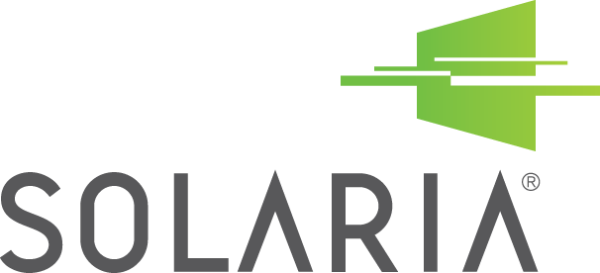
Contact details:
Nandita Geerdink, Resolution Communications for Solaria
Tel. : + 1 415 269 4493; email: Nandita@resolutioncommunications.com

