NSG Group and visualplanet™ to exhibit integrated smart mirror at ISE 2017
PRESS RELEASE
31st January, 2017

NSG Group and visualplanet™ announced on 31st of January that the two companies will exhibit an integrated solution for the fast growing smart mirror market at ISE 2017.
Visitors to ISE will have the opportunity to test NSG Group’s generation 2 Pilkington MirroView™, a non-metallic mirror suitable for projected capacitive touch-screen applications, on an interactive mirror at the booth. This interactive mirror uses the recently launched multi-user visualplanet™ touchfoil™, a class-leading touch resolution and a state-of-the-art controller. Combined, the two features offer pinpoint touch accuracy and unrivalled versatility in fulfilling the bespoke needs of OEM integrators, worldwide. Generation 2 Pilkington MirroView™ also exhibits a neutral reflected colour, ideal for mirror applications.
Visualplanet™ is a globally recognised leader of large-format touch sensor technology with design, research, development and manufacturing based in the UK. The company’s touchfoil™ products have been widely in use by the world’s largest manufacturers, systems integrators and specialists since 2003. The visualplanet™ touchfoil™ is a clear large format, projected capacitance, flexible film touch sensor is applied to glass to add interactive capabilities.
NSG Group is one of the world’s largest manufacturers of glass and glazing products for the Architectural, Automotive and Technical Glass sectors.
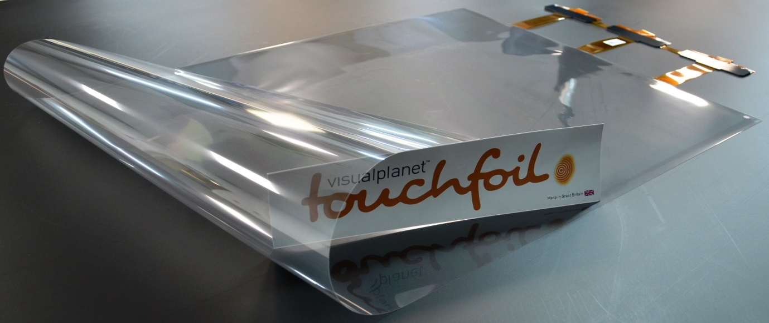
The multi-user touchfoil™ delivers lightning fast 6 ms touch performance through glass of up to 10 mm, with the precision to drive mouse-designed operating systems with a finger. It offers real-time movement and programmable palm rejection through up to 40 independent touch points, across a range of sizes from 15-55 inches. Its durability, speed, transparency, clarity, accuracy and overall performance are the most advanced in the 14 years history of visualplanet™.
The combination of the generation 2 Pilkington MirroView™ and touchfoil™ offers versatility for an extensive range of public-facing terminals, including smart mirrors in retail and bathroom applications, self-service ticketing, vending, gaming, way finding, multiuser tables and kiosks.
Technical data for the interactive mirror:
Mirror (generation 2 Pilkington MirroView™) | Sensor (visualplanet™ touchfoil™)
Reflection: 64% | Size: 15” – 55”
Transmission: 25% | Aspect Ratio: 16:9
Neutral reflected colour | Touch points: up to 40
Size: 1500 mm x 600 mm | Speed of Response: 6 ms
Thickness: 6 mm | Glass Operation: 2-10 mm
Others: Fully toughenable | Others: 10 micron sensing wires

Please visit us at booth 8-K390 to see the interactive generation 2 Pilkington MirroView™ demo and our other high performance glass solutions.
For more information please visit: http://www.pilkington.com/en/digitalsignage
END
Note to editors:
The NSG Group is one of the world's leading manufacturers of glass and glazing systems in three major business areas: Automotive, Architectural and Technical Glass. Automotive serves the original equipment, aftermarket replacement, and specialized transport glazing markets. Architectural supplies glass for architectural applications, solar energy and digital signage and displays. Technical Glass products include very thin glass for displays, lenses and light guides for printers, and glass fiber, used in battery separators and engine timing belts. We have major market shares in most building and automotive product markets of the world, with a broad geographic reach, enabling us to respond to customers whose operations, particularly in the case of Automotive OE, are increasingly global. Geographically, 39 percent of the Group's sales are in Europe, 30 percent in Japan and 16 percent in North America, with the remaining 15 percent being generated in the rest of the world.

