Pilkington Botanical launched to boost growth in greenhouses
27 January 2022

PRESS RELEASE
NSG Group has launched a new range of glass products focused specifically at the horticultural market.
The new Pilkington Botanical™ range comprises of glass-based solutions aimed at boosting crop growth or dealing with the issues faced by growers. It offers the tried, trusted and durable qualities of the Pilkington Optifloat™ and Pilkington Optiwhite™ glass alongside innovative durable coatings on glass.
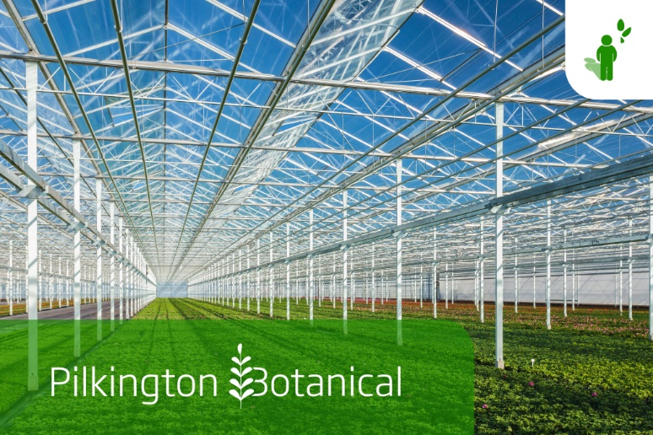
The optimisation of light entering the greenhouse is a high priority for maximising crop yields. The Pilkington Botanical™ range offers products that preserve or even boost the light transmission.
To evaluate and optimise lighting conditions it is important to consider both direct light and light under different angles of incidence. The NSG Group is focused on maintaining a high hemispherical transmission (a more accurate measurement for photosynthetic active light entering through the glass) on all products in the Pilkington Botanical™ range.
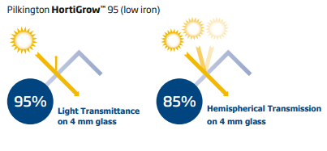
Pilkington Botanical™ provides the perfect solution for greenhouses, conservatories and winter gardens. It includes a wide range of glass solutions dedicated to protect, enhance and facilitate better propagation and crop growth, as well as options to toughen, bend or laminate. Pilkington Optifloat™ Clear already has an impressive 91% light transmission but this can be boosted further by opting for the low iron Pilkington Optiwhite™ glass or by using the Pilkington HortiGrow™ range which uses durable anti-reflective coatings on one or both sides of the glass to boost the transmission up to a potential 98%.
The NSG Group is looking to develop new products to introduce to this versatile range based on the needs of the customer. Additional functionality such as light diffusion and coatings that ensure that the glass stays cleaner for longer between costly cleaning cycles can also be added.
Coatings and surfaces can be fine-tuned based on specific requirements. The diverse nature of plants and crops and varying climates means that no single solution will fit all. Whatever the requirements are the NSG Group is encouraging growers and specifiers to get in touch so the needs of their individual project can be discussed and supported.
To find out more visit: https://botanical.pilkington.com/
Note to Editors:
About the NSG Group (Nippon Sheet Glass Co., Ltd. and its group companies)
The NSG Group is the world's leading supplier of glass and glazing systems in the business areas of Architectural, Automotive and Creative Technology. In 2006 it acquired the leading global glass supplier, Pilkington, and today, the Group has principal operations around the world and sales in over 100 countries. Architectural manufactures and supplies architectural glass as well as glass for the solar energy and other sectors. Automotive serves the original equipment (OE) and aftermarket replacement (AGR) glazing markets. Creative Technology comprises several discrete businesses, including lenses and light guides for printers and scanners, and specialty glass fiber products such as glass cord for timing belts and glass flake.
For more information about NSG Group visit: www.nsg.com
For more information about Pilkington glass products visit: www.pilkington.com
Contact details:
Email: botanical@pilkington.com

