Pilkington Fire Protection at InnoTrans 2022
25 August 2022
PRESS RELEASE
Meet the Pilkington Fire Protection Glass team, from 20 - 23 September 2022, at InnoTrans in Berlin, the world’s leading trade fair for transport technology.
The team’s dedicated stand will present Pilkington Pyrostop® R, Pilkington Pyrodur® R and Pilkington Pyroclear® R, its fire-resistant glass products, which are used in rail-bound vehicles. Available with screen printings, scratch protection films and other additional features, the products have all been proven according to various international test requirements.
Significantly, a large number of our products are compliant with EN 45545-2, the European railway standard for safety that tests hazard levels in case of fire. All tested products achieved the highest-class HL 3, as they greatly reduce the spread of fire, causing only a low rate of heat release in the event of a blaze, as well as producing low levels of smoke toxicity and smoke density.
You will find us in Hall 1.1 at booth no 120.
We are looking forward to your visit!
You can find more information about the trade fair at www.innotrans.de
END

Photography:
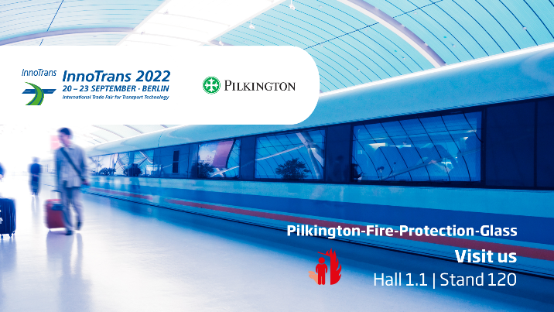
Copyrights: Pilkington Deutschland AG
PR/36/22

