NEWS RELEASE

NSG’s Solar Glass Float Furnace in U.S. Starts Operation

TOKYO (November XX, 2020) - NSG Group announced today the float furnace to produce TCO (transparent conductive oxide) coated glass for solar panels in Luckey, Ohio has started operation. Due to the pandemic, the inaugural furnace lighting ceremony was held virtually and streamed live over the company social media platforms.

The new 500,000 square foot glass production facility was built as part of the 38 billion yen investment plan announced in May 2018 to expand production capacity of TCO glass to support the growing solar market.

The investment is part of a long-term supply agreement with U.S.-headquartered First Solar, Inc., which operates the Western Hemisphere’s largest photovoltaic (PV) solar manufacturing footprint in Northwest Ohio.

Manufactured with the online coating technology, in which a conductive oxide on the glass surface is formed during its passage through the float line, NSG’s TCO glass is very durable with a wide range of applications. Online coating also enables cost-effective production of coated glass in high volume.

With the expanded supply capability for VA products, such as solar glass and other products, NSG Group intends to drive its growth strategy while supporting the expansion of renewable energy.

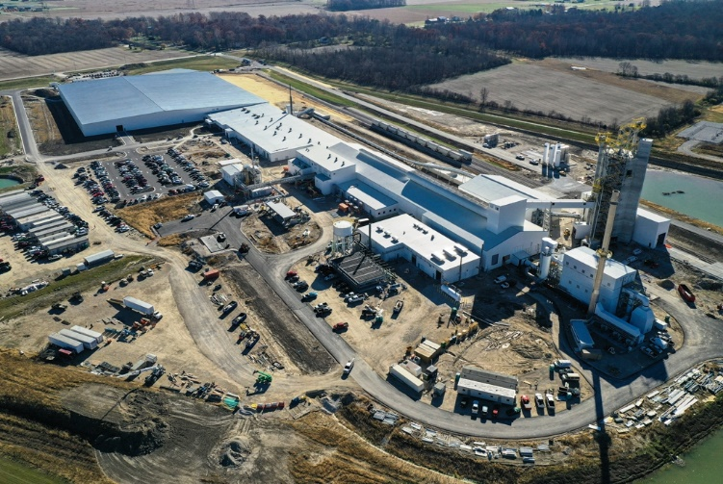
Photo from light-up ceremony: Drone photo of plant:
About NSG Group
NSG Group (Nippon Sheet Glass, Co., Ltd.) is one of the world’s largest manufacturers of glass and glazing products for the architectural, automotive industry and technical glass sectors. With around 27,000 employees, NSG Group has principal operations worldwide and sales in over 100 countries. http://www.nsg.com
MEDIA CONTACT
Please visit Media Contacts on NSG Group website from the following link to find out an appropriate contact for your region. https://www.nsg.com/en/media/media-contacts

